May 21, 2012

Caleb C. Wistar
New York State Department of Health
Tower Building, Room 1084 ESP
Albany, NY 12237

Dear Mr. Wistar:

I’m pleased to submit this letter of endorsement for the New York State Department of Health’s application to the Health Resources and Services Administration for the Affordable Care Act State Loan Repayment Program (SLRP) funding opportunity. My understanding is that New York State’s proposed state programs, for which matching SLRP funding is requested, will provide funding for up to 63 primary care clinicians to assist them in repaying their educational loans in exchange for practicing in a health professional shortage area for a period of 2 to 5 years.

The New York State Oral Health Coalition is a broad-based association comprised of more than 130 county health departments, community health centers, dental schools, state oral health officials, hospitals, insurers, health advocates, and policy leaders from across New York State. Established in 2006, the Coalition was assembled for the purpose of developing the New York State Oral Plan to address the burden of oral disease and develop strategies to address issues related to policy development, prevention, access to care, workforce, communications, surveillance, and research. Coalition members continue to meet to vigorously implement the New York State Oral Health Plan in order to maximize oral health for all New Yorkers. The Workforce Committee assesses and addresses labor concerns such as supply and demand, diversity and distribution, professional practice issues, education and training necessary to meet current and future needs; and opportunities for recruitment and retention.

The New York State Oral Health Coalition is pleased to serve an important role in marketing the State Loan Repayment Program to our membership base. To assist you in recruiting providers, we will post program notices in our organization’s publications and other communications channels, including our website, online discussion boards, bulk emails, and group meetings, to promote the program.

I would like to express my appreciation to you for reaching out to the New York State Oral Health Coalition in the planning stages of this application and including us in your dissemination efforts. The New York State Oral Health Coalition looks forward to collaborating with the New York State Department of Health to improve access to health care in underserved communities by addressing persistent workforce shortages in the State for dentists, dental hygienists, and other health professionals.

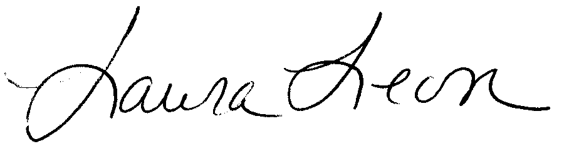

Sincerely,

Laura Leon
Chair

